Light exposure-related behaviors can predict chronotype, sleep quality, trouble in memory and concentration: a PLS-SEM Analysis

Mushfiqul Anwar Siraji1, Vineetha Kalavally2, & Shamsul Haque1

1 Monash University, Department of Psychology, Jeffrey Cheah School of Medicine and Health Sciences, Malaysia

2 Monash University, Department of Electrical and Computer Systems Engineering, Malaysia, Selangor, Malaysia

Correspondence concerning this article should be addressed to Shamsul Haque, Monash University Malaysia,Jalan Lagoon Selatan, 47500 Bandar Sunway,Selangor Darul Ehsan, Malaysia.. E-mail: [shamsul@monash.edu](mailto:shamsul@monash.edu)

Abstract

One or two sentences providing a **basic introduction** to the field, comprehensible to a scientist in any discipline.

Two to three sentences of **more detailed background**, comprehensible to scientists in related disciplines.

One sentence clearly stating the **general problem** being addressed by this particular study.

One sentence summarizing the main result (with the words “**here we show**” or their equivalent).

Two or three sentences explaining what the **main result** reveals in direct comparison to what was thought to be the case previously, or how the main result adds to previous knowledge.

One or two sentences to put the results into a more **general context**.

Two or three sentences to provide a **broader perspective**, readily comprehensible to a scientist in any discipline.

*Keywords:* keywords

*Word count:* X

Light exposure-related behaviors can predict chronotype, sleep quality, trouble in memory and concentration: a PLS-SEM based analysis

Objectives: We pose the following questions: 1. What are the influences of light exposure-related behavior on our chronotype? 2. What are the influences of light exposure-related behavior on sleep quality? 3. What are the influences of light exposure-related behavior on trouble in memory and concentration? 4. What are the influences of light exposure-related behavior on mood?

## Hypothesis

Light exposure related behaviour will successfully predict: Trouble in Concentration and memory Chronotype and Sleep quality Mood

# Methods

## Participants

We conducted a large-scale online survey on Malaysian residents. The exclusion-inclusion criteria for respondents to be included in this study were: (1) Malaysian resident >18 years of age and able to read and write English (2) no physiological and psychological disorder (self reported). Three hundred and sixty-six adults completed the survey. The completion rate of our survey was 87% thus, we excluded 45 participants, due to incomplete data. We further excluded 19 participants based on our exclusion-inclusion criteria. Thus, we used data from 301 participants for further processing.

A priori power analysis was done to determine adequate sample sizes with GPower 3.0 [1]. To achieve an effect size of 0.15 [2] and 80% statistical power and =0.05, for a multiple liner regression with 13 predictors a total sample size of 131 individuals was needed. Also, the maximum number of items per factor in our model was six. To detect a minimum value of 0.10 for a factor with six items with 80% statistical power and =0.05 at least 130 participants are required [3]. Our sample size exceeded these recommendations. Out of 301 participants, 72.43% (218) were female ranging in age from 18 to 59 (26.85±8.07) and 27.57% (83) were male with an age range between 18 to 74 years (30.35±12.14). 78.66% of the participants were unmarried. Most of the participants were students (71.42%). 56.29% of participants had at least a bachelor’s degree.

## Material

### Light exposure behavior assessment.

Light exposure-related behaviors were measured using the short form of Light Exposure Behavior Assessment [4]. The short form contains five factors with 19 items. Light Exposure Behavior Assessment (LEBA) measures the propensity of different light exposure-related behaviors in the last one month retrospectively using a five-point Likert-type response scale (1 = never; 2 = rarely; 3 = sometimes; 4 = often; 5 = always). The first factor of LEBA (F1) investigates the propensity of wearing blue light filter glasses indoors and outdoors. The second factor (F2) measures how much time spend under sunlight. The third-factor measures (F3) our habit of using smart devices in bed. The fourth factor(F4) looks into our habit of controlling light exposure before bedtime. The last factor (F5) captures our habit of using different electric light sources throughout the day. All 19 items of LEBA and the participants’ responses to them are shown in Figure 1.

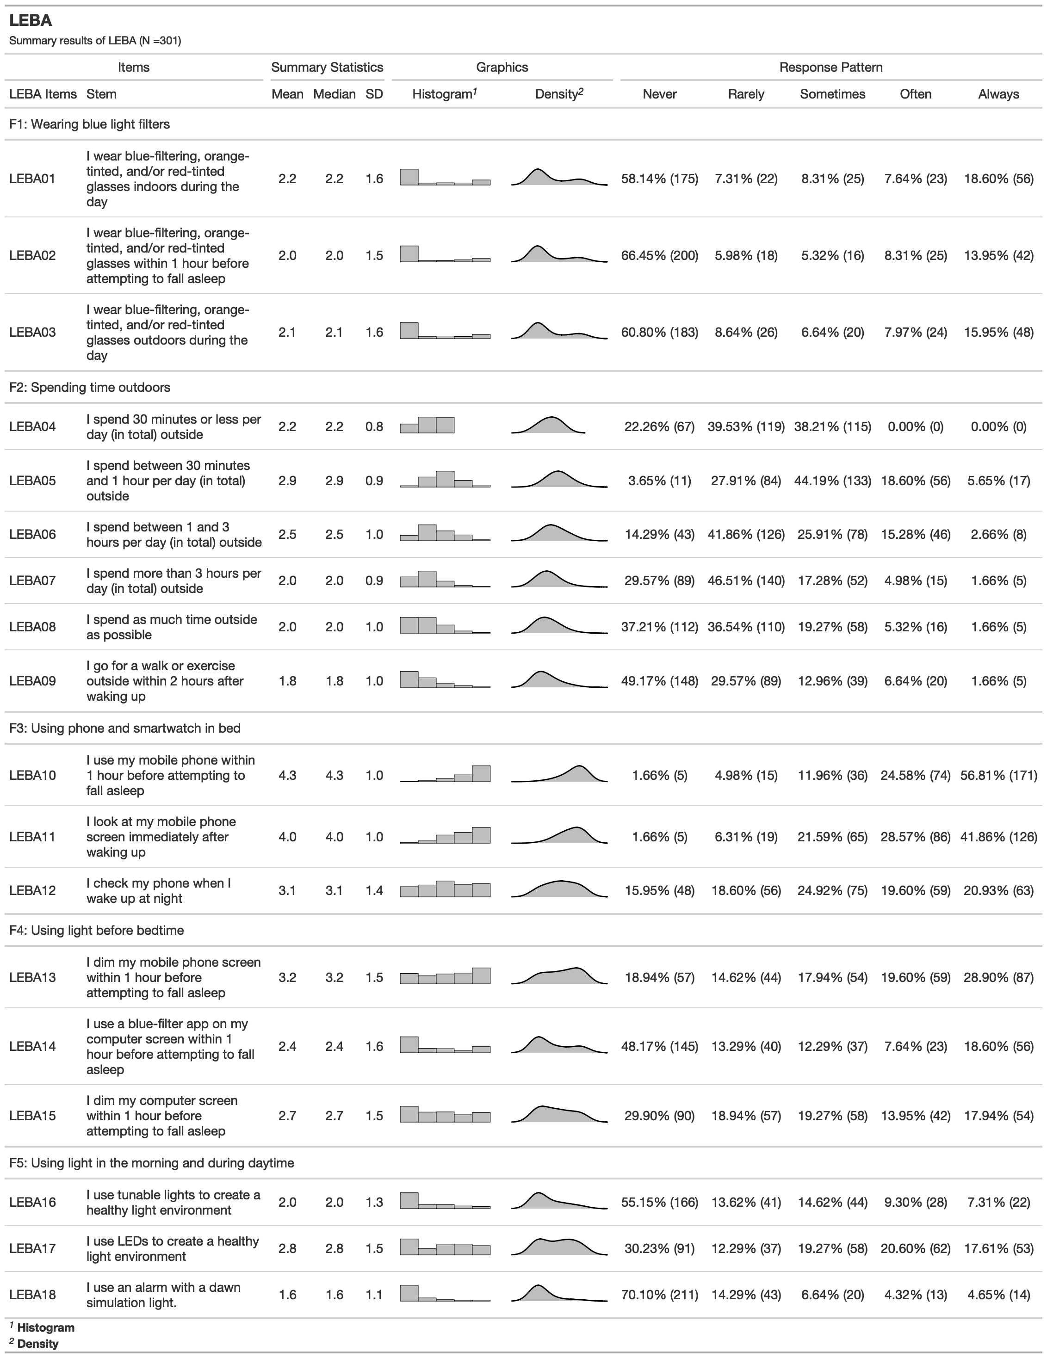

*Figure* *1.*  Response distribution of LEBA

### Positive and Negative Affect Schdule.

The positive and negative affect schedule (PANAS) [5]was used to measure positive and negative affect. PANAS is comprised of two 10-item mood scales measuring positive affect (PA) and negative affect (NA). In this study participants rate their positive and negative affect based on the last one month retrospectively using a five-point Likert type response scale (1 = very slightly/not at all; 2 = a little; 3 = moderately; 4 = quite a bit; 5 = extremely).

### Trouble in Memory and Concentration.

To assess trouble in memory and concentration, we used two items with four-point Likert-type response options. These two items asked the participants about the propensity of their memory and concentration difficulty in the last month (0=Absent; 1=Slight; 2=Moderate; 3=Severe)

### Pittsburgh Sleep Quality Index.

We used the Pittsburgh Sleep Quality Index (PSQI)[6] to measure the sleep quality of the participants. PSQI measures seven domains of sleep to differentiate “poor” from “good” sleep. Participants responded to the PSQI using a Likert type responses option ranging from zero the three, whereby 3 reflects the negative extreme on the Likert Scale. A sum of scores equal to or greater than five indicates poor sleep quality. Though Buysse et al. [6] reported a one-factor structure of the scale, it is evidenced that the factor structure of PSQI varies from one factor to three factors [7]. Dunleavy et al. [8] in their study recommended using a two-factor model: perceived sleep quality (PSQ) and sleep efficiency (SE) while measuring the sleep quality among Singapore citizens. In this study, we followed their recommended structure.

### Morningness-Eveningness Questionnaire.

Chronotype was measured using Morningness-Eveningness questionnaire (MEQ) [9]. MEQ consists of 19 questions and the scores range from 16 to 86. A higher score indicates more morning propensity. Caci et al. [10] reported a four-factor structure of MEQ: peak time (PT), morning affect (MA), retiring (RT) and rising (RI) in s student sample.

## Data Collection

The project received ethics clearance from Monash University Human Research Ethics Committee (Project ID: 14786). A quantitative cross-sectional fully anonymous online survey was conducted. Participants were invited via email and social media (i.e., LinkedIn, Twitter, and Facebook) with the attachment of an Explanatory Statement. It was mentioned in the explanatory statement that their participation was voluntary and that they could withdraw from participation at anytime without being penalized. If the participants expressed happiness with the Explanatory Statement, a survey link was sent to them. At the beginning of the survey, their consent was recorded digitally. The survey took around 15 to 20 minutes for which they were not compensated. We collected the survey data between April 2022 and September 2022.

## Analytic Strategy

Our aim was to predict chronotype, sleep quality and trouble in memory and concentration from the light exposure-related behavior. The partial least squares structural equation modeling (PLS-SEM) is best suited to formulate such a predictive model [11]. We used partial least squares structural equation modelling in R [12] using “SEMinR” package [13].

### Measurement Model Assessment.

First, we assessed the quality of the measurement model. We excluded items with factor loading < 0.40 to increase the robustness of the measurement model [13]. Second, we estimated the internal consistency reliability estimates of each construct. We reported both the lower bound estimate of reliability- Cronbach’s coefficient and the upper bound estimate of reliability-construct reliability (CR). Both Cronbach’s and CR coefficient values range between 0 to 1, where higher values represent better reliability. As a general guideline, Cronbach’s above .70 is considered satisfactory [14, 15] and a value above .50 is considered acceptable [16]. CR coefficient value of 0.60 and above indicates a satisfactory reliability [13].

Third, we assessed the convergent and discriminant validity of the measurement model. We used the average variance extracted (AVE) value of each construct to assess convergent validity. To indicate satisfactory convergent validity the AVE value should be 0.50 and above [17]. However, an AVE value lower than 0.50 but with a composite reliability coefficient higher than 0.60 also indicates an acceptable convergent validity [17]. We assessed the discriminant validity of the measurement model by comparing the square root of each construct’s AVE with its correlation with other constructs [17]. The square root of the AVE values of each construct should be higher than its correlation with other constructs. We have also reported the heterotrait-monotrait ratio (HTMT) of correlations of the construct as additional proof of discriminant validity. For conceptually similar constructs the HTMT value should be lower than .90 and for constructs that are conceptually distinct, the HTMT value should be lower than .80 [18].

### Structural Model Assessment.

First, we assessed the collinearity of the constructs in our structural model by calculating variance inflation factor (VIF) values. VIF>3 indicates probable collinearity issues [18]. Next, we estimated the path coefficients of the structural model using a bootstrapping approach with 10000 sub-samples and reported the significant total effects (p<0.05) observed in our model. Lastly, we reported the adjusted as a measure of the explanatory power of our model and values for the constructs as a predictive relevance index of our model. For assessing the explanatory power, we followed the guidelines of Falk and Miller [19]: values 0.10 indicates adequate explanatory power. Further, we have categorized the values following the guidelines of Cohen [2]: 0.02 (weak), 0.13 (moderate), and 0.26 (substantial). For predictive relevance >0 indicates good relevance. We further assessed the fitted model’s predictive power by K-fold cross-validation using the function from the “SEMinR” package [13]. provides the root-mean-square error (RMSE) and respective linear-regression model (LM) benchmarks for all indicators. We assessed the model’s predictive power by following the guideline of Hair [13]: (i) high predictive power: All indicators in the fitted PLS-SEM model have lower RMSE values compared to the linear regression (LM) benchmarks (ii) medium predictive power: the majority(≥50%) of the indicators have lower RMSE values than LM (iii) low predictive power: less than 50% of the indicator have lower RMSE value than LM (iv) no predictive power: no indicator has lower RMSE value than LM model (Sarstedt et al., 2021). Figure 2 depicts the analyses steps we followed.

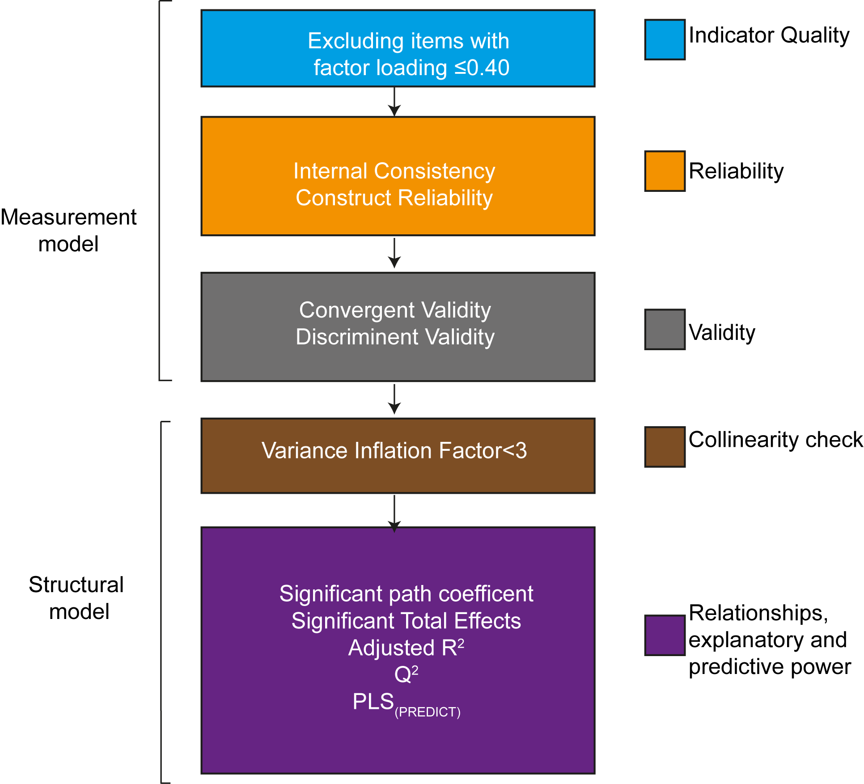

*Figure* *2.*  Analyses Steps

# Results

## Measurement Model

We excluded one item from LEBA (item04) and four items from MEQ (items 06, 10,16,12) due to weak factor loadings (<0.40) (SA1). All renaming factor loadings were significant. The results of the measurement model assessment are shown in Table 3. The sleep Efficiency construct exhibited poor reliability in terms of coefficient Cronbach’s alpha coefficient (=.0.48) but had a satisfactory construct reliability (CR=0.79). All other constructs exhibited acceptable to satisfactory internal consistency in terms of Cronbach’s coefficient [0.51-0.94] and construct reliability[0.72-0.96]. In terms of convergent validity, AVEs for all constructs were higher than .50 except LEBA factor 2, negative affect, PSQ, PT and RI. However, all constructs' construct reliability were higher than .60 and AVEs were less than their respective construct reliability indicating sufficient reliability and convergent validity. To establish the discriminant validity, we summarized the square root of each constructs’ AVE and compared them with its correlation with other constructs in Table 4. All constructs’ square root of AVE values were greater than their inter-construct correlation indicating satisfactory discriminant validity. Table 5 summarises the HTMT values and also indicated satisfactory discriminant validity (HTMT<.80).

## Structural Model

VIF for all constructs were bellow 3 indicating no possible collinearity problem. Table-- reports the significant (T-value >1.906, p<0.05) path coefficients and total effects observed in our model.

### Total effects of light exposure-related behavior.

We observed a positive significant total effect of LEBA F1 on perceived sleep quality (PSQ) (= 0.11) and negative effect on MA (= -0.16). There are significant positive total effect of LEBA F2 on PA (= 0.32), PT (= 0.15), RT (= 0.15), RI (= 0.14). LEBA F3 had significant positive total effect on negative affect (= 0.17), PSQ (= 0.21). LEBA F3 also exhibited significant positive effect on trouble in memory (= 0.20) and concentration (= 0.23). LEBA F3 also exhibited a negative total effect on all four chronotype factors (PT, MA, RI, RI). LEBA F5 showed significant total effect on PA (= 0.16) and PSQ (= -0.17). Our model did not yield any significant total effect of LEBA factor 4 on sleep quality, chronotype, mood and trouble in memory and concentration.

### Total effects of mood, chronotype and sleep quality.

Our model indicated a significant negative total effect of a positive affect on trouble in concentration (= -0.18). Negative affect had a significant positive total effect on PSQ (= 0.28), trouble in memory (= 0.43) and concentration (= 0.40). Both PSQ and MA also showed significant positive total effects on trouble in memory (PSQ:= 0.17; MA: = -0.04)) and concentration (PSQ:= 0.26; MA:= -0.06). Figure 3 depicts significant path coefficients.

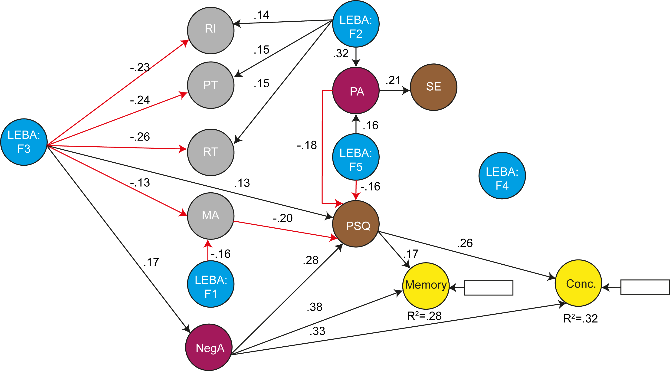

*Figure* *3.*  Analyses Steps

### Explanatory and predictive Power of the fitted model.

Our fitted model exhibited substantial explanatory power for PSQ (26.79%) and trouble in concentration (30.35% ). Moderate explanatory power was observed for PA (13.85%) and Memory (25.51%). For the two factors of chronotype we observed weak but adequate explanatory power for PT (10.96%) and RT (12.45%). MA, RI, SE and negative affect did not had adequate explanatory power. The values of the respective constructs indicated good predictive relevance (>0) for all constructs except positive and negative affect (<0) and RI (close to 0). function indicated our model had medium predictive power with 61.36% of the indicators having RMSE value lower than the LM benchmark.

# Discussion

# References

1. Faul F, Erdfelder E, Lang A-G, Buchner A. G* Power 3: A flexible statistical power analysis program for the social, behavioral, and biomedical sciences. Behavior research methods. 2007;39(2):175-91.

2. Cohen J. Statistical power analysis for the behavioral sciences. 2nd ed. ed: Hillsdale, NJ : L. Erlbaum Associates; 1988.

3. Hair JF, Jr., Hult GTM, Ringle CM, Sarstedt M. A primer on partial least squares structural equation modeling (PLS-SEM). 2nd ed: Thousand Oaks, California : SAGE Publications Inc; 2017.

4. Siraji MA, Lazar RR, van Duijnhoven J, Schlangen LJM, Haque S, Kalavally V, et al., editors. Light exposure behaviour assessment (LEBA): a novel self-reported instrument to capture light exposure-related behaviour. CIE Australia Lighting Research Conference; 2022; Australia

5. Watson D, Clark LA, Tellegen A. Development and Validation of Brief Measures of Positive and Negative Affect: The PANAS Scales. Journal of personality and social psychology. 1988;54(6):1063-70.

6. Buysse DJ, Reynolds CF, Monk TH, Berman SR, Kupfer DJ. The Pittsburgh sleep quality index: A new instrument for psychiatric practice and research. Psychiatry Res. 1989;28(2):193-213.

7. Manzar MD, BaHammam AS, Hameed UA, Spence DW, Pandi-Perumal SR, Moscovitch A, et al. Dimensionality of the Pittsburgh Sleep Quality Index: A systematic review. Health Qual Life Outcomes. 2018;16(1):89-.

8. Dunleavy G, Bajpai R, Tonon AC, Chua AP, Cheung KL, Soh C-K, et al. Examining the Factor Structure of the Pittsburgh Sleep Quality Index in a Multi-Ethnic Working Population in Singapore. Int J Environ Res Public Health. 2019;16(23):4590.

9. Horne JA, Östberg O. A self-assessment questionnaire to determine morningness-eveningness in human circadian rhythms. International journal of chronobiology. 1976.

10. Caci H, Deschaux O, Adan A, Natale V. Comparing three morningness scales: Age and gender effects, structure and cut-off criteria. Sleep Med. 2008;10(2):240-5.

11. Hair Jr JF, Matthews LM, Matthews RL, Sarstedt M. PLS-SEM or CB-SEM: updated guidelines on which method to use. International Journal of Multivariate Data Analysis. 2017;1(2):107-23.

12. Team RC. R: A Language and Environment for Statistical Computing. 2021.

13. Hair JF. Partial least squares structural equation modeling (PLS-SEM) using R : a workbook. Hult GTM, Ringle CM, Sarstedt M, Danks NP, Ray S, editors. Cham: Cham : Springer International Publishing AG; 2021.

14. MacCallum RC, Roznowski M, Mar CM, Reith JV. Alternative strategies for cross-validation of covariance structure models. Multivariate behavioral research. 1994;29(1):1--32.

15. MacKenzie SB, Podsakoff PM, Jarvis CB. The problem of measurement model misspecification in behavioral and organizational research and some recommended solutions. Journal of applied psychology. 2005;90(4):710.

16. Hinton P, McMurray I, Brownlow C. SPSS explained2014.

17. Fornell C, Larcker DF. Evaluating structural equation models with unobservable variables and measurement error. Journal of marketing research. 1981;18(1):39--50.

18. Henseler J, Ringle CM, Sarstedt M. A new criterion for assessing discriminant validity in variance-based structural equation modeling. Journal of the academy of marketing science. 2015;43(1):115--35.

19. Falk RF, Miller NB. A primer for soft modeling.1992.

Tables

Table 1: Demographics

| **Characteristic** | **Female**, N = 218 | **Male**, N = 83 |
| --- | --- | --- |
| Age | 27 (8) | 30 (12) |
| Religion |  |  |
| Atheist | 23 (11%) | 7 (8.4%) |
| Buddhist | 99 (45%) | 35 (42%) |
| Christian | 36 (17%) | 13 (16%) |
| Hindu | 21 (9.6%) | 11 (13%) |
| Muslim | 39 (18%) | 17 (20%) |
| Ethnicity |  |  |
| Malaysian Chinese | 138 (63%) | 46 (55%) |
| Malaysian Indian | 19 (8.7%) | 13 (16%) |
| Malaysian Malay | 26 (12%) | 7 (8.4%) |
| Others | 35 (16%) | 17 (20%) |
| Marital Status |  |  |
| Single | 180 (83%) | 56 (67%) |
| Married | 37 (17%) | 27 (33%) |
| Divorced | 1 (0.5%) | 0 (0%) |
| Education |  |  |
| Doctor of Philosophy (PhD) | 43 (20%) | 13 (16%) |
| Master’s degree | 38 (17%) | 22 (27%) |
| post grad diploma | 1 (0.5%) | 0 (0%) |
| Bachelor’s degree | 129 (59%) | 41 (49%) |
| Diploma | 5 (2.3%) | 4 (4.8%) |
| Pre-university | 1 (0.5%) | 2 (2.4%) |
| Secondary School | 1 (0.5%) | 1 (1.2%) |
| Occupation |  |  |
| Student | 165 (76%) | 50 (60%) |
| Work | 42 (19%) | 31 (37%) |
| Neither | 11 (5.0%) | 2 (2.4%) |
| Community Stance | 7.07 (1.87) | 7.00 (1.85) |
| Sleep Quality |  |  |
| Good Sleep | 69 (32%) | 24 (29%) |
| Poor Sleep | 149 (68%) | 59 (71%) |
| Chronotype |  |  |
| Definite Evening | 8 (3.7%) | 1 (1.2%) |
| Intermediate | 144 (66%) | 60 (72%) |
| Moderate Evening | 43 (20%) | 13 (16%) |
| Moderate Morning | 23 (11%) | 9 (11%) |

Table 2:

Results of Measurement assessment

| Constructs | Factor Loading | Cronbach’s alpha | CR | AVE | R2 | Q2 |
| --- | --- | --- | --- | --- | --- | --- |
| Trouble in Memory | 1.00 | 1.00 | 1.00 | 1.00 |  |  |
| Trouble in Concentration | 1.00 | 1.00 | 1.00 | 1.00 |  |  |
| PSQ |  | 0.60 | 0.73 | 0.36 |  |  |
| PSQ1 | 0.72 |  |  |  |  |  |
| PSQ2 | 0.44 |  |  |  |  |  |
| PSQ3 | 0.51 |  |  |  |  |  |
| PSQ4 | 0.42 |  |  |  |  |  |
| PSQ5 | 0.81 |  |  |  |  |  |
| Sleep Efficiency |  | 0.48 | 0.79 | 0.66 |  |  |
| Sleep_efficieny1 | 0.86 |  |  |  |  |  |
| Sleep_efficieny2 | 0.75 |  |  |  |  |  |
| LEBA F1 |  | 0.94 | 0.96 | 0.66 |  |  |
| LEBA_F1_item1 | 0.95 |  |  |  |  |  |
| LEBA_F1_item2 | 0.95 |  |  |  |  |  |
| LEBA_F1_item3 | 0.94 |  |  |  |  |  |
| LEBA F2 |  | 0.71 | 0.80 | 0.45 |  |  |
| LEBA_F2_item1 | 0.46 |  |  |  |  |  |
| LEBA_F2_item2 | 0.73 |  |  |  |  |  |
| LEBA_F2_item3 | 0.62 |  |  |  |  |  |
| LEBA_F2_item4 | 0.69 |  |  |  |  |  |
| LEBA_F2_item5 | 0.79 |  |  |  |  |  |
| LEBA F3 |  | 0.71 | 0.84 | 0.64 |  |  |
| LEBA_F3_item1 | 0.85 |  |  |  |  |  |
| LEBA_F3_item2 | 0.86 |  |  |  |  |  |
| LEBA_F3_item3 | 0.68 |  |  |  |  |  |
| LEBA F4 |  | 0.67 | 0.82 | 0.60 |  |  |
| LEBA_F4_item1 | 0.73 |  |  |  |  |  |
| LEBA_F4_item2 | 0.69 |  |  |  |  |  |
| LEBA_F4_item3 | 0.89 |  |  |  |  |  |
| LEBA F5 |  | 0.51 | 0.74 | 0.50 |  |  |
| LEBA_F5_item1 | 0.76 |  |  |  |  |  |
| LEBA_F5_item2 | 0.55 |  |  |  |  |  |
| LEBA_F5_item3 | 0.78 |  |  |  |  |  |
| MEQ F1 |  | 0.71 | 0.79 | 0.39 |  |  |
| MEQ_F1_item1 | 0.53 |  |  |  |  |  |
| MEQ_F1_item2 | 0.75 |  |  |  |  |  |
| MEQ_F1_item3 | 0.58 |  |  |  |  |  |
| MEQ_F1_item4 | 0.50 |  |  |  |  |  |
| MEQ_F1_item5 | 0.79 |  |  |  |  |  |
| MEQ_F1_item6 | 0.55 |  |  |  |  |  |
| MEQ F2 |  | 0.72 | 0.84 | 0.64 |  |  |
| MEQ_F2_item1 | 0.87 |  |  |  |  |  |
| MEQ_F2_item2 | 0.80 |  |  |  |  |  |
| MEQ_F2_item3 | 0.73 |  |  |  |  |  |
| MEQ F3 |  | 0.60 | 0.77 | 0.46 |  |  |
| MEQ_F3_item1 | 0.76 |  |  |  |  |  |
| MEQ_F3_item2 | 0.61 |  |  |  |  |  |
| MEQ_F3_item3 | 0.78 |  |  |  |  |  |
| MEQ_F3_item4 | 0.53 |  |  |  |  |  |
| MEQ F4 |  | 0.51 | 0.80 | 0.67 |  |  |
| MEQ_F4_item1 | 0.85 |  |  |  |  |  |
| MEQ_F4_item2 | 0.78 |  |  |  |  |  |
| Positive Affect |  | 0.92 | 0.93 | 0.57 |  |  |
| PA1 | 0.74 |  |  |  |  |  |
| PA2 | 0.72 |  |  |  |  |  |
| PA3 | 0.84 |  |  |  |  |  |
| PA4 | 0.81 |  |  |  |  |  |
| PA5 | 0.71 |  |  |  |  |  |
| PA6 | 0.63 |  |  |  |  |  |
| PA7 | 0.80 |  |  |  |  |  |
| PA8 | 0.77 |  |  |  |  |  |
| PA9 | 0.72 |  |  |  |  |  |
| PA10 | 0.82 |  |  |  |  |  |
| Negative Affect |  | 0.86 | 0.89 | 0.45 |  |  |
| NegA1 | 0.67 |  |  |  |  |  |
| NegA2 | 0.72 |  |  |  |  |  |
| NegA3 | 0.64 |  |  |  |  |  |
| NegA4 | 0.74 |  |  |  |  |  |
| NegA5 | 0.46 |  |  |  |  |  |
| NegA6 | 0.68 |  |  |  |  |  |
| NegA7 | 0.65 |  |  |  |  |  |
| NegA8 | 0.73 |  |  |  |  |  |
| NegA9 | 0.58 |  |  |  |  |  |
| NegA10 | 0.78 |  |  |  |  |  |

*Note.* All factor loadings are significant (p<0.05)

Table 3:

Discriminant validity assessment using the Fornell and Larcker Criterion

| Constructs* | L1 | L2 | L3 | L4 | L5 | PA | NegA | PSQ | SE | PT | MA | RT | RI | Memory | Concentration |
| --- | --- | --- | --- | --- | --- | --- | --- | --- | --- | --- | --- | --- | --- | --- | --- |
| L1 | **0.95** |  |  |  |  |  |  |  |  |  |  |  |  |  |  |
| L2 | 0.05 | **0.67** |  |  |  |  |  |  |  |  |  |  |  |  |  |
| L3 | -0.10 | -0.21 | **0.80** |  |  |  |  |  |  |  |  |  |  |  |  |
| L4 | 0.17 | 0.12 | 0.02 | **0.77** |  |  |  |  |  |  |  |  |  |  |  |
| L5 | 0.11 | 0.22 | -0.17 | 0.29 | **0.71** |  |  |  |  |  |  |  |  |  |  |
| PA | -0.06 | 0.35 | -0.12 | 0.02 | 0.21 | **0.76** |  |  |  |  |  |  |  |  |  |
| NegA | 0.09 | 0.02 | 0.14 | 0.05 | 0.13 | -0.19 | **0.67** |  |  |  |  |  |  |  |  |
| PSQ | 0.08 | -0.06 | 0.23 | 0.02 | -0.18 | -0.33 | 0.37 | **0.60** |  |  |  |  |  |  |  |
| SE | 0.02 | 0.01 | -0.06 | -0.03 | 0.02 | 0.22 | -0.08 | -0.04 | **0.81** |  |  |  |  |  |  |
| PT | -0.07 | 0.22 | -0.28 | 0.01 | 0.17 | 0.33 | -0.17 | -0.26 | 0.10 | **0.63** |  |  |  |  |  |
| MA | -0.12 | 0.12 | -0.15 | 0.06 | 0.16 | 0.31 | -0.20 | -0.35 | 0.18 | 0.41 | **0.80** |  |  |  |  |
| RT | -0.01 | 0.21 | -0.31 | -0.09 | 0.16 | 0.27 | -0.08 | -0.18 | 0.10 | 0.63 | 0.37 | **0.68** |  |  |  |
| RI | 0.05 | 0.20 | -0.28 | -0.01 | 0.15 | 0.18 | -0.05 | -0.11 | 0.11 | 0.35 | 0.20 | 0.34 | **0.82** |  |  |
| Memory | 0.01 | -0.09 | 0.20 | 0.11 | 0.08 | -0.16 | 0.47 | 0.32 | -0.10 | -0.22 | -0.28 | -0.22 | -0.10 | **1.00** |  |
| Concentration | 0.01 | -0.05 | 0.23 | 0.06 | -0.04 | -0.26 | 0.46 | 0.43 | -0.15 | -0.26 | -0.31 | -0.16 | -0.17 | 0.52 | **1.00** |

Note. *The bold numbers listed diagonally are the square root of the AVE of the constructs. The off-diagonals are the inter-correlations of the constructs. For discriminant validity. The diagonal values should be larger than the values of the off-diagonals.

Table 4:

Discriminant validity assessment using the HTMT

| Constructs* | L1 | L2 | L3 | L4 | L5 | PA | NegA | PSQ | SE | PT | MA | RT | RI | Memory |
| --- | --- | --- | --- | --- | --- | --- | --- | --- | --- | --- | --- | --- | --- | --- |
| L2 | 0.09 |  |  |  |  |  |  |  |  |  |  |  |  |  |
| L3 | 0.13 | 0.26 |  |  |  |  |  |  |  |  |  |  |  |  |
| L4 | 0.21 | 0.23 | 0.09 |  |  |  |  |  |  |  |  |  |  |  |
| L5 | 0.19 | 0.40 | 0.28 | 0.52 |  |  |  |  |  |  |  |  |  |  |
| PA | 0.07 | 0.41 | 0.15 | 0.09 | 0.31 |  |  |  |  |  |  |  |  |  |
| NegA | 0.11 | 0.16 | 0.21 | 0.11 | 0.29 | 0.25 |  |  |  |  |  |  |  |  |
| PSQ | 0.12 | 0.28 | 0.38 | 0.14 | 0.34 | 0.35 | 0.49 |  |  |  |  |  |  |  |
| SE | 0.09 | 0.06 | 0.17 | 0.17 | 0.13 | 0.32 | 0.13 | 0.23 |  |  |  |  |  |  |
| PT | 0.09 | 0.25 | 0.34 | 0.15 | 0.29 | 0.41 | 0.26 | 0.34 | 0.21 |  |  |  |  |  |
| MA | 0.15 | 0.15 | 0.20 | 0.08 | 0.27 | 0.36 | 0.25 | 0.43 | 0.31 | 0.52 |  |  |  |  |
| RT | 0.14 | 0.27 | 0.46 | 0.14 | 0.30 | 0.36 | 0.17 | 0.34 | 0.25 | 0.94 | 0.54 |  |  |  |
| RI | 0.08 | 0.26 | 0.44 | 0.14 | 0.28 | 0.27 | 0.15 | 0.34 | 0.22 | 0.52 | 0.33 | 0.57 |  |  |
| Memory | 0.04 | 0.12 | 0.24 | 0.13 | 0.10 | 0.16 | 0.49 | 0.35 | 0.16 | 0.26 | 0.32 | 0.26 | 0.14 |  |
| Concentration | 0.03 | 0.10 | 0.28 | 0.06 | 0.14 | 0.27 | 0.49 | 0.45 | 0.21 | 0.29 | 0.35 | 0.20 | 0.23 | 0.52 |

* All HTMT values are lower than 0.80

Table 5:

Structural model assessment

| Path Coefficients* | Original Est. | Bootstrap Mean | Bootstrap SD | T Stat. | 2.5% CI | 97.5% CI |
| --- | --- | --- | --- | --- | --- | --- |
| L1  ->  MA | -0.16 | -0.16 | 0.06 | -2.44 | -0.28 | -0.03 |
| L2  ->  PA | 0.32 | 0.32 | 0.05 | 6.21 | 0.22 | 0.42 |
| L2  ->  PT | 0.15 | 0.15 | 0.07 | 2.27 | 0.02 | 0.28 |
| L2  ->  RT | 0.15 | 0.15 | 0.06 | 2.29 | 0.02 | 0.27 |
| L2  ->  RI | 0.14 | 0.14 | 0.06 | 2.33 | 0.02 | 0.25 |
| L3  ->  NegA | 0.17 | 0.17 | 0.06 | 2.84 | 0.05 | 0.29 |
| L3  ->  PSQ | 0.13 | 0.13 | 0.06 | 2.24 | 0.01 | 0.24 |
| L3  ->  PT | -0.24 | -0.24 | 0.05 | -4.39 | -0.35 | -0.14 |
| L3  ->  MA | -0.13 | -0.13 | 0.06 | -2.24 | -0.24 | -0.01 |
| L3  ->  RT | -0.26 | -0.27 | 0.05 | -4.83 | -0.37 | -0.16 |
| L3  ->  RI | -0.23 | -0.23 | 0.06 | -3.79 | -0.35 | -0.11 |
| L5  ->  PA | 0.16 | 0.16 | 0.06 | 2.45 | 0.03 | 0.28 |
| L5  ->  PSQ | -0.16 | -0.16 | 0.06 | -2.59 | -0.27 | -0.03 |
| PA  ->  PSQ | -0.18 | -0.18 | 0.06 | -3.02 | -0.30 | -0.06 |
| PA  ->  SE | 0.22 | 0.21 | 0.07 | 3.08 | 0.07 | 0.35 |
| NegA  ->  PSQ | 0.28 | 0.29 | 0.06 | 4.83 | 0.17 | 0.40 |
| NegA  ->  Memory | 0.38 | 0.38 | 0.06 | 6.63 | 0.26 | 0.49 |
| NegA  ->  Concentration | 0.33 | 0.32 | 0.06 | 5.87 | 0.21 | 0.43 |
| PSQ  ->  Memory | 0.17 | 0.18 | 0.06 | 3.11 | 0.07 | 0.29 |
| PSQ  ->  Concentration | 0.26 | 0.26 | 0.06 | 4.60 | 0.15 | 0.37 |
| MA  ->  PSQ | -0.20 | -0.20 | 0.06 | -3.31 | -0.31 | -0.08 |

*\** Only significant paths are reported

Table 6:

Significant Total effects

| Total Effects* | Original Est. | Bootstrap Mean | Bootstrap SD | T Stat. | 2.5% CI | 97.5% CI |
| --- | --- | --- | --- | --- | --- | --- |
| L1  ->  PSQ | 0.11 | 0.12 | 0.05 | 2.06 | 0.01 | 0.22 |
| L1  ->  MA | -0.16 | -0.16 | 0.06 | -2.44 | -0.28 | -0.03 |
| L2  ->  PA | 0.32 | 0.32 | 0.05 | 6.21 | 0.22 | 0.42 |
| L2  ->  PT | 0.15 | 0.15 | 0.07 | 2.27 | 0.02 | 0.28 |
| L2  ->  RT | 0.15 | 0.15 | 0.06 | 2.29 | 0.02 | 0.27 |
| L2  ->  RI | 0.14 | 0.14 | 0.06 | 2.33 | 0.02 | 0.25 |
| L3  ->  NegA | 0.17 | 0.17 | 0.06 | 2.84 | 0.05 | 0.29 |
| L3  ->  PSQ | 0.21 | 0.21 | 0.06 | 3.53 | 0.09 | 0.32 |
| L3  ->  PT | -0.24 | -0.24 | 0.05 | -4.39 | -0.35 | -0.14 |
| L3  ->  MA | -0.13 | -0.13 | 0.06 | -2.24 | -0.24 | -0.01 |
| L3  ->  RT | -0.26 | -0.27 | 0.05 | -4.83 | -0.37 | -0.16 |
| L3  ->  RI | -0.23 | -0.23 | 0.06 | -3.79 | -0.35 | -0.11 |
| L3  ->  Memory | 0.20 | 0.19 | 0.06 | 3.12 | 0.06 | 0.31 |
| L3  ->  Concentration | 0.23 | 0.23 | 0.06 | 3.89 | 0.11 | 0.34 |
| L5  ->  PA | 0.16 | 0.16 | 0.06 | 2.45 | 0.03 | 0.28 |
| L5  ->  PSQ | -0.17 | -0.17 | 0.07 | -2.38 | -0.30 | -0.02 |
| PA  ->  PSQ | -0.18 | -0.18 | 0.06 | -3.02 | -0.30 | -0.06 |
| PA  ->  SE | 0.22 | 0.21 | 0.07 | 3.08 | 0.07 | 0.35 |
| PA  ->  Concentration | -0.15 | -0.15 | 0.06 | -2.56 | -0.27 | -0.04 |
| NegA  ->  PSQ | 0.28 | 0.29 | 0.06 | 4.83 | 0.17 | 0.40 |
| NegA  ->  Memory | 0.43 | 0.43 | 0.05 | 8.26 | 0.33 | 0.53 |
| NegA  ->  Concentration | 0.40 | 0.40 | 0.05 | 7.86 | 0.30 | 0.50 |
| PSQ  ->  Memory | 0.17 | 0.18 | 0.06 | 3.11 | 0.07 | 0.29 |
| PSQ  ->  Concentration | 0.26 | 0.26 | 0.06 | 4.60 | 0.15 | 0.37 |
| MA  ->  PSQ | -0.20 | -0.20 | 0.06 | -3.31 | -0.31 | -0.08 |
| MA  ->  Memory | -0.04 | -0.04 | 0.02 | -2.37 | -0.08 | -0.01 |
| MA  ->  Concentration | -0.06 | -0.06 | 0.02 | -2.98 | -0.11 | -0.03 |

*\** Only significant effects are reported

Supplementary Table

SA T1:

Results of Measurement assessment (Supplemental table)

| Constructs | Factor Loading | Cronbach’s alpha | CR | AVE |
| --- | --- | --- | --- | --- |
| Trouble in Concentration | 1.00 | 1.00 | 1.00 | 1.00 |
| Trouble in Memory | 1.00 | 1.00 | 1.00 | 1.00 |
| PSQ |  | 0.60 | 0.73 | 0.36 |
| PSQ1 | 0.72 |  |  |  |
| PSQ2 | 0.44 |  |  |  |
| PSQ3 | 0.51 |  |  |  |
| PSQ4 | 0.43 |  |  |  |
| PSQ5 | 0.81 |  |  |  |
| Sleep Efficiency |  | 0.48 | 0.79 | 0.66 |
| Sleep_efficieny1 | 0.86 |  |  |  |
| Sleep_efficieny2 | 0.75 |  |  |  |
| LEBA Factor 1 |  | 0.94 | 0.96 | 0.66 |
| LEBA_F1_item1 | 0.95 |  |  |  |
| LEBA_F1_item2 | 0.95 |  |  |  |
| LEBA_F1_item3 | 0.94 |  |  |  |
| LEBA Factor 2 |  |  |  |  |
| LEBA_F2_item1 | 0.31 | 0.69 | 0.78 | 0.39 |
| LEBA_F2_item2 | 0.47 |  |  |  |
| LEBA_F2_item3 | 0.72 |  |  |  |
| LEBA_F2_item4 | 0.63 |  |  |  |
| LEBA_F2_item5 | 0.68 |  |  |  |
| LEBA_F2_item6 | 0.78 |  |  |  |
| LEBA Factor 3 |  | 0.71 | 0.84 | 0.64 |
| LEBA_F3_item1 | 0.85 |  |  |  |
| LEBA_F3_item2 | 0.86 |  |  |  |
| LEBA_F3_item3 | 0.68 |  |  |  |
| LEBA Factor 4 |  | 0.67 | 0.82 | 0.60 |
| LEBA_F4_item1 | 0.75 |  |  |  |
| LEBA_F4_item2 | 0.69 |  |  |  |
| LEBA_F4_item3 | 0.88 |  |  |  |
| LEBA Factor 5 |  | 0.51 | 0.74 | 0.50 |
| LEBA_F5_item1 | 0.76 |  |  |  |
| LEBA_F5_item2 | 0.54 |  |  |  |
| LEBA_F5_item3 | 0.79 |  |  |  |
| MEQ F1 |  | 0.71 | 0.79 | 0.39 |
| MEQ_F1_item1 | 0.53 |  |  |  |
| MEQ_F1_item2 | 0.75 |  |  |  |
| MEQ_F1_item3 | 0.58 |  |  |  |
| MEQ_F1_item4 | 0.50 |  |  |  |
| MEQ_F1_item5 | 0.79 |  |  |  |
| MEQ_F1_item6 | 0.55 |  |  |  |
| MEQ F2 |  | 0.53 | 0.70 | 0.48 |
| MEQ_F2_item1 | 0.85 |  |  |  |
| MEQ_F2_item2 | 0.79 |  |  |  |
| MEQ_F2_item3 | 0.73 |  |  |  |
| MEQ_F2_item4 | -0.15 |  |  |  |
| MEQ F3 |  | 0.42 | 0.61 | 0.29 |
| MEQ_F3_item1 | 0.75 |  |  |  |
| MEQ_F3_item2 | 0.58 |  |  |  |
| MEQ_F3_item3 | 0.78 |  |  |  |
| MEQ_F3_item4 | 0.38 |  |  |  |
| MEQ_F3_item5 | 0.54 |  |  |  |
| MEQ_F3_item6 | -0.26 |  |  |  |
| MEQ_F3_item7 | 0.06 |  |  |  |
| MEQ F3 |  | 0.51 | 0.80 | 0.67 |
| MEQ_F4_item1 | 0.85 |  |  |  |
| MEQ_F4_item2 | 0.78 |  |  |  |
| Positive Affect |  | 0.92 | 0.93 | 0.57 |
| PA1 | 0.74 |  |  |  |
| PA2 | 0.72 |  |  |  |
| PA3 | 0.84 |  |  |  |
| PA4 | 0.81 |  |  |  |
| PA5 | 0.71 |  |  |  |
| PA6 | 0.63 |  |  |  |
| PA7 | 0.80 |  |  |  |
| PA8 | 0.77 |  |  |  |
| PA9 | 0.72 |  |  |  |
| PA10 | 0.82 |  |  |  |
| Negative Affect |  | 0.86 | 0.89 | 0.45 |
| NegA1 | 0.67 |  |  |  |
| NegA2 | 0.72 |  |  |  |
| NegA3 | 0.64 |  |  |  |
| NegA4 | 0.74 |  |  |  |
| NegA5 | 0.46 |  |  |  |
| NegA6 | 0.68 |  |  |  |
| NegA7 | 0.65 |  |  |  |
| NegA8 | 0.73 |  |  |  |
| NegA9 | 0.58 |  |  |  |
| NegA10 | 0.78 |  |  |  |